W-12
YEAR 8 SCIENCE
BIOLOGICAL SCIENCE
TEST 1: MICROSCOPES + CELLS

NAME: MARK: 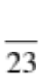

Select equipment to collect data with accuracy appropriate to the task.
(Mult. choice Q1-4, Part 2 Q1)

Distinguishing plant cells from animal or fungal cells.
Mark | ND | NW | C | O
Mark Range | 0-2 | 3-5 | 6-8 | 9-11
Identifying structures within cells and describing their function.
(Mult. choice Q5-10, Part 2 Q2-3)

Mark | ND | NW | C | O
Mark Range | 0-1 | 2-5 | 6-9 | 10-12

Part 1: Multiple Choice

Choose the correct answer for each question and write its letter in the appropriate box.

1. The simplest units of life that we could call alive are:
MULTIPLE CHOICE ANSWERS
1
2
3
4
5
6
7
8
9
10

(a) atoms.
(b) cells.
(c) molecules.
(d) proteins.

2. The object to be studied and placed on the stage of the microscope is described
as the:

(a) specimen.
(b) image.
(c) clip.
(d) slide.

3. The total magnification of a specimen viewed with a 10x eyepiece and 40x
objective lens is:

(a) 4000x
(b) 30x
(c) 400x
(d) 50x

4. The area that can be seen through the eyepiece of a microscope is the _____.

(a) field of view
(b) image
(c) magnification
(d) specimen
5. Which of the following is not found in animal cells?

(a) Chloroplasts.
(b) Cell membrane.
(c) Vacuoles.
(d) Nucleus.

6. A human cheek cell is best described as an example of _____.

(a) an animal cell
(b) a protist
(c) an organism
(d) a plant cell

7. Muscle cells provide energy. They would contain a large number of _____ to ensure they could fulfil
their function.

(a) vacuoles
(b) membranes
(c) mitochondria
(d) chloroplasts

8. Plant cells are able to carry out photosynthesis in particular structures called:

(a) chloroplasts.
(b) carbon dioxide.
(c) sunlight.
(d) water.

9. What is the function of the cell membrane?

(a) It controls what substances pass in and out of the cell.
(b) It surrounds the cell and allows it to store substances.
(c) It makes the cell strong and stops it tearing.
(d) It controls all the activities of the cell.

10. Which statement about cells is incorrect?

(a) Most cells can be seen with the naked eye.
(b) Both plants and animals contain cells.
(c) Plant cells may contain chlorophyll.
(d) There are many different kinds of cells.

Part 2: Short Answer

Write the answer to each question in the spaces provided.

1. Label the parts of the diagram as given in the table.

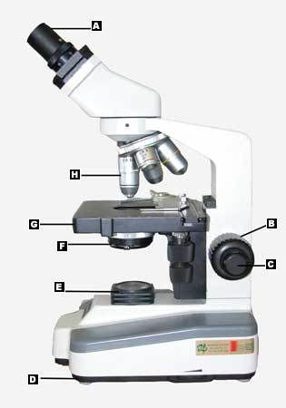
LABEL | NAME
A
B
C
D
E
G
H

(7)

2. Label the following diagrams of cells. A list of possible names of organelles is given below.

Nucleus Cell Membrane Cell Wall Nucleolus Ribosome Mitochondria Vacuole
Endoplasmic Reticulum Golgi Complex Vesicles Centrioles Lysosomes Cytoplasm
Chloroplast
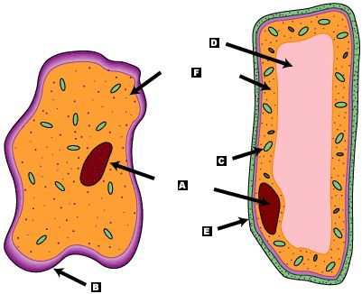
LABEL | NAME
A
B
C
D
E
F

(3)
3. Complete the following table showing the name and function of cell organelles.

Part of Cell | Function
 | Contains chlorophyll and is the site for photosynthesis.
 | Jelly-like liquid that fills up most of the space in a cell.
 | Only found in plants – gives the cell strength and helps plants stay upright.
 | Storage area for substances needed by the cell.
 | Controls substances entering and leaving cells.
 | Controls the activities of the cell.

(3)

